Here is the WiFi scan at all the end points of the mesh’s section.
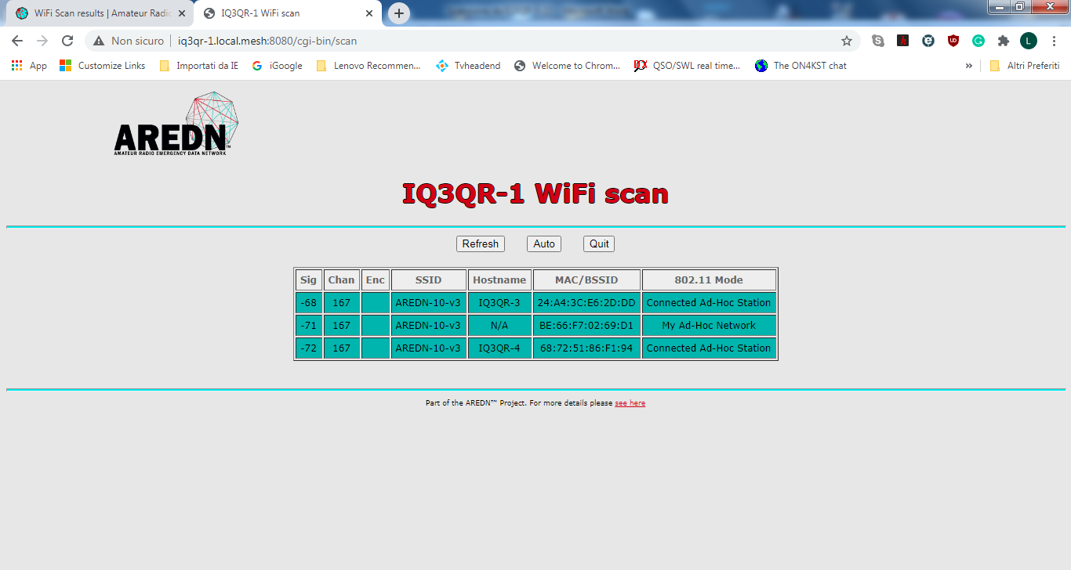
IQ3QR-1 (5.835 GHz) on top of a hill with a 120° sector linked to IQ3QR-4 and IQ3QR-3.
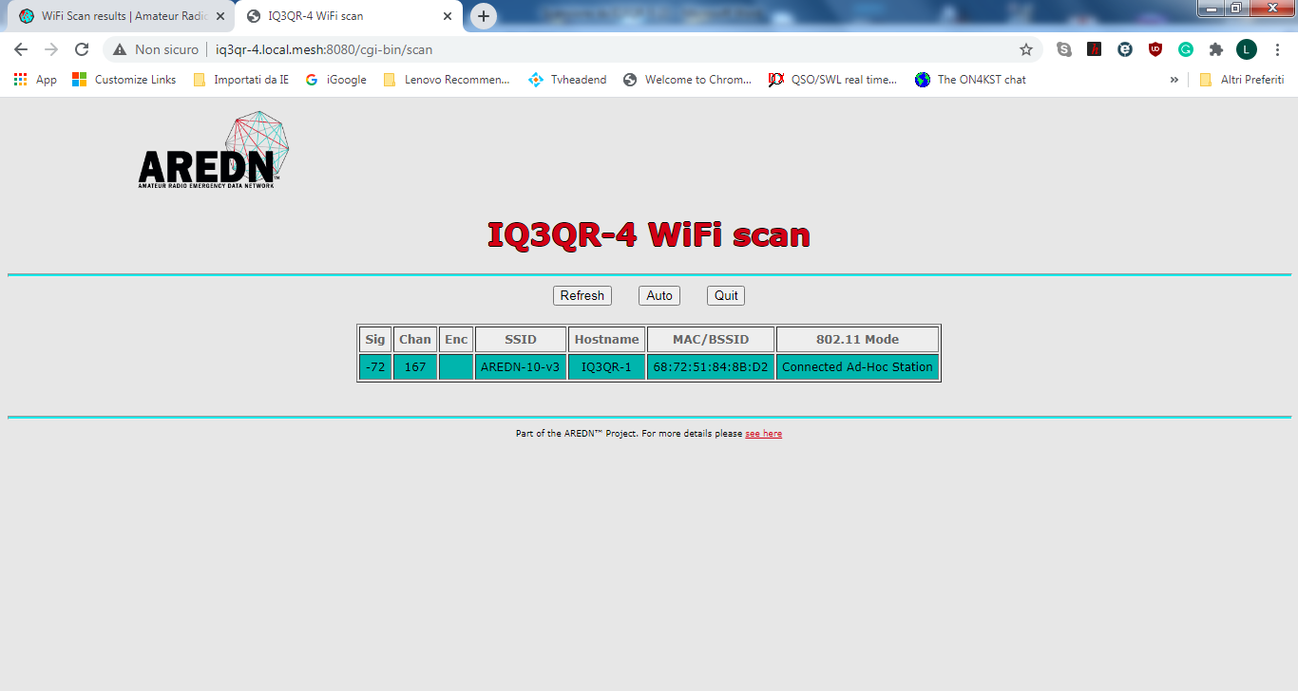

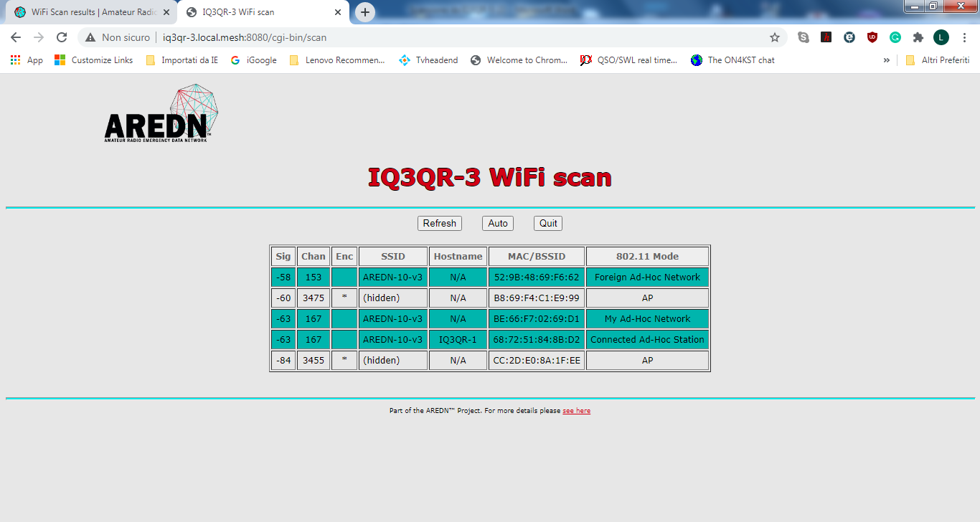
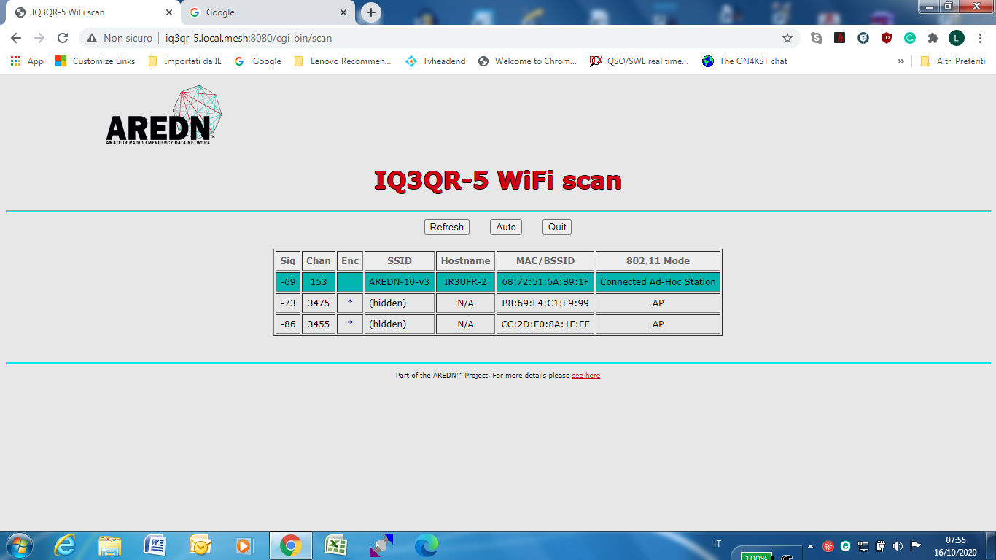
IQ3QR-5 (5.765 GHz) and IQ3QR-3 (5.835 GHz) are located on the same site and linked D.t.D. with a 802.1q switch. IQ3QR-3 with a 25 dBi dish is pointing to North beaming at IQ3QR-1, IQ3QR-5 with a 30 dBi parabolic reflector pointing to east beaming to IR3UFR-2.
Only the scan from the two: IQ3QR-3 and IQ3QR-5 are affected by the problem of the AP at 3.455 GHz and at 3.475 GHz.

