AREDN Mesh network near Treviso – Northern Italy
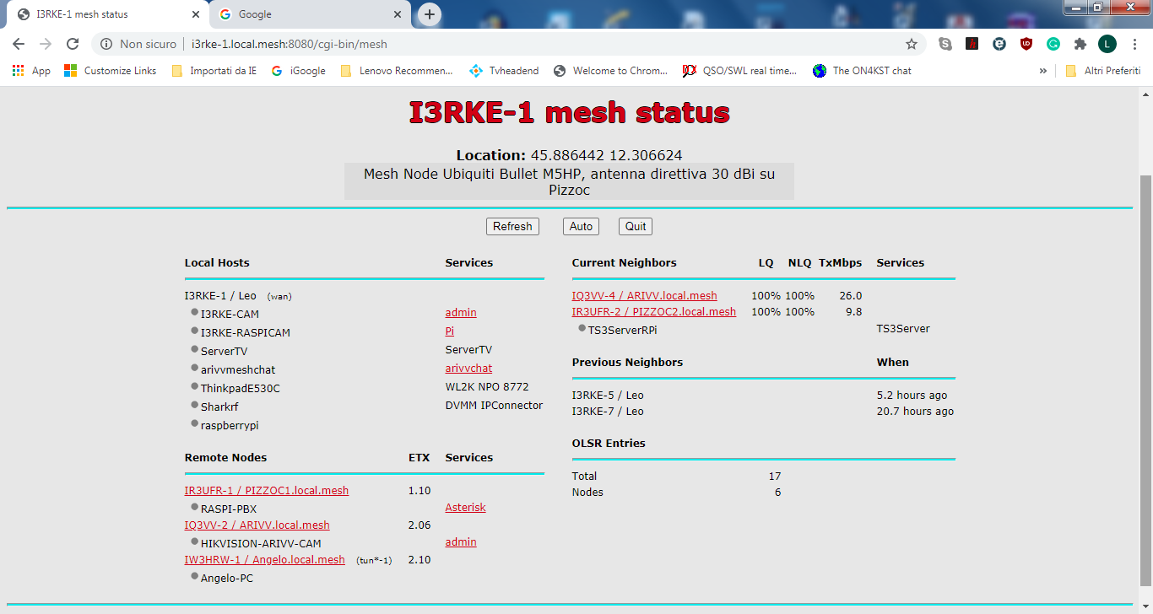
The nodes IR3UFR-2 and IR3UFR-1 are collocated at the top of an hill, working on two frequencies (5,765 and 5,835 GHz), connected DtD with an 802.1Q switch. As you can appreciate both are visible from my own node I3RKE-1.
The node IQ3VV-4 (operating at 5,765 GHz) is also linked with IR3UFR-1 and IR3UFR-2 and is also connected DtD with the node IQ3VV-3 (operating at 5,835 GHz) , but not visible. Consider that I am doing a test before to install the two new nodes IQ3VV-3 and IQ3VV-4 at top of another hill in order to extend the mesh. And would like to be sure that all is working fine.
At the moment the node IQ3VV-3 is not pointing any other node. Is the problem due to the fact that the IQ3VV-3 is not connected to other nodes via WiFi ?

Please see next page.
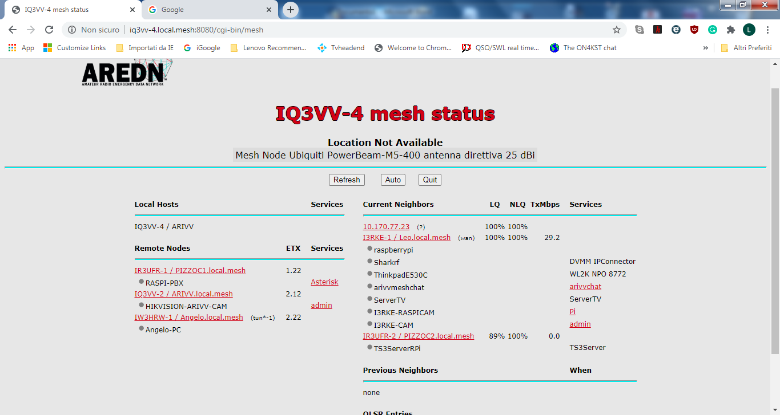
From the point of view of IQ3VV-4, the node IQ3VV-3 is visible on the mesh only as I.P. address.

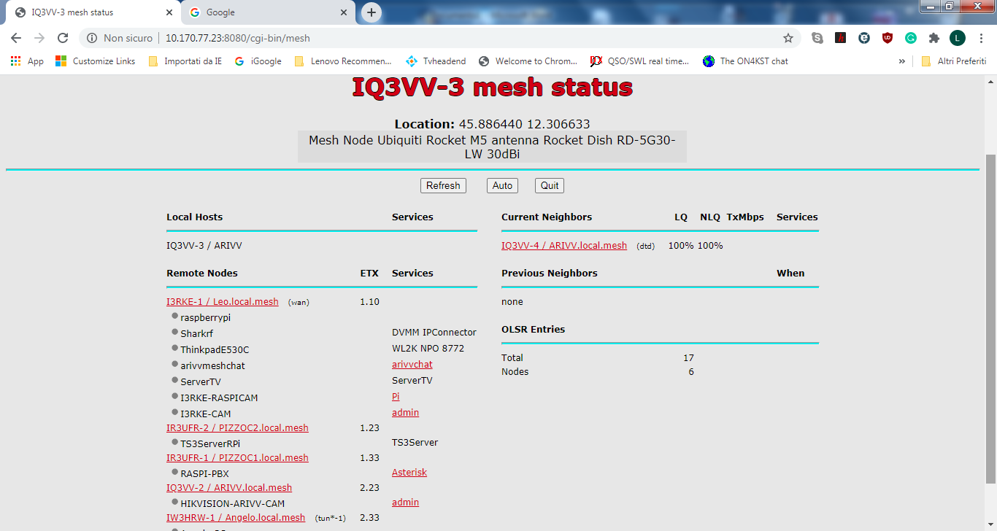
If I enter into the node IQ3VV-3, I can see the mesh with the node IQ3VV-3 connected as DtD.

