Setting up the MikroTik CSS106 / RB260GSP Managed Switch with POE out on ports 2-5
Don McCubbin, KM4DC
My goal is to get the MikroTik switch to create 2 VLANs. VLAN1 connects the Internet to the AREDN node; in my case a Ubiquiti Nanostation M2. VLAN 10 allows LAN devices to connect to the AREDN node and the Internet. I just got this working and there may be a better way to do this, but for now, it seems to work. Comments welcomed. The setup of the switch is quite different from any other switch I’ve used.
For initial access to the switch set pc Ethernet i/f to 192.168.88.2/24 and use web browser to go to 192.168.88.1. The Initial login-in is admin and no password. I used Port1 for my PC connection because there is no POE out on port1.
There are a series of tabs across the window. I only changed information in tabs shown below for the setup. Be sure to use the APPLY ALL button to save changes before leaving the tab.
LINK TAB
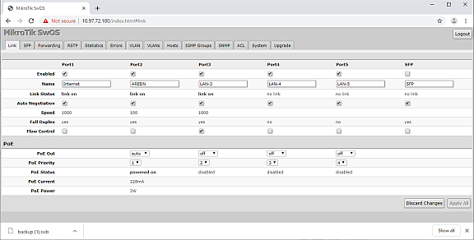
Enabled: The 5 Ethernet ports are enabled and the SFP port is empty and not enabled.
Name: Pick a name for each port or leave default name.
Link Status: indicates whether the “Link on” or “no link”.
Auto Negotiation: I left this set to “Auto”.
Speed: Shows the negotiated speed.
Full Duplex: Shows “yes” as negotiated solution.
Flow Control: I turned this off by unchecking the box for each port.
POE
You can leave this on ATUO. I tried it on Auto and it seems to work without burning out my interface. I set POE on for my AREDN node and OFF for the other ports. Port 1 is POE IN and does not provide POE out. That’s why my AREDN node is on Port 2.
FORWARDING
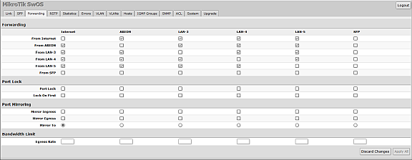
I disabled forwarding to the SFP. Forwarding is the default setting for all Ethernet ports.
VLAN TAB
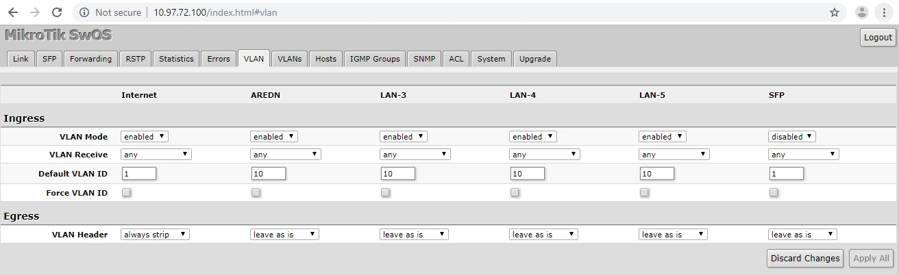
INGRESS
I disabled the SFP. Other ports are “enabled”.
VLAN Receive is set to “ANY”.
Default VLAN ID for Port1/Internet is set to 1. Ports 2-5 are set to VLAN 10.
Force VLAN ID is set to off/unchecked.
EGRESS
VLAN Header: Port1/Internet is set to “always strip. VLAN 2-5 are set to “leave as-is”
VLANS TAB
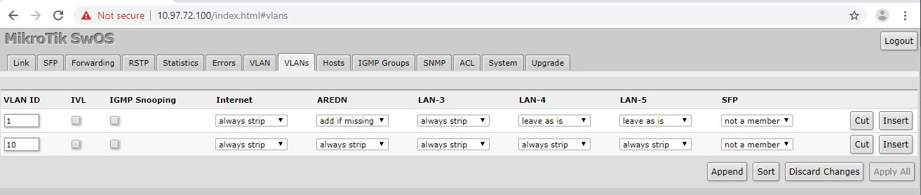
The VLANS tab is where the VLANS are created and identified. Use the APPEND button to create the first VLAN. After the first VLAN is created there are APPEND (after), INSERT (before) button, and CUT buttons.
VLAN1, Port 1/Internet is set to “always strip” the header (tag). For Port 2/AREDN I set it to “insert if missing”. For ports 3-5 I used “leave as is”.
For VLAN10, Ports 1-5 are set to “always strip”.
SYSTEM TAB
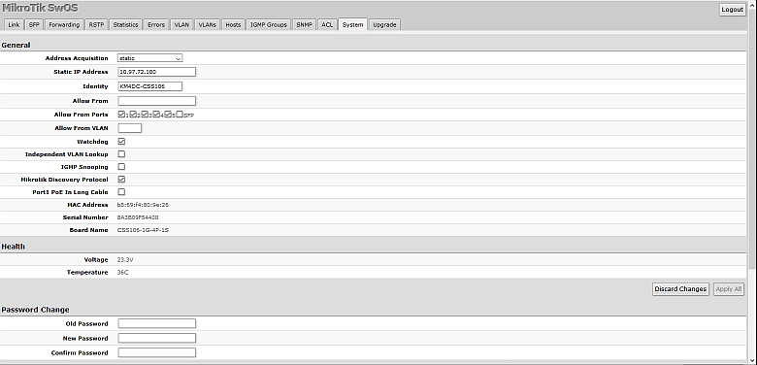
The System Tab
GENERAL
Address Acquisition: I set this to “static” and added an address to Static IP Address. I tried DHCP and DHCP with fallback but found the DHCP timed out before it got an address. I believe the switch DHCP waits 10 seconds before giving up. Given that the switch is providing power to the AREDN node, this isn’t enough time for the AREDN node to boot and then provide an address to the switch. I checked the AREDN node to get an unused address and then reserved the address on the AREDN node.
Identity: I set this to the same name I gave the switch in the AREDN node.
The Allow From choices allows access to the switch from ip addresses, VLANs or ports.
MAC address, unit serial number, and board name.
Health shows the POE voltage and unit temperature.
Password Change: The “Old password” is blank and then add and conform a new password.
At this point I saved a BACKUP of the config. That button is near the bottom of the System tab.
Then I powered off the MikroTik switch and connected the Internet to Port1, my AREDN node to Port2, and my PC to Port 3.
Fingers crossed and power applied.
FROM THE AREDN SWITCH
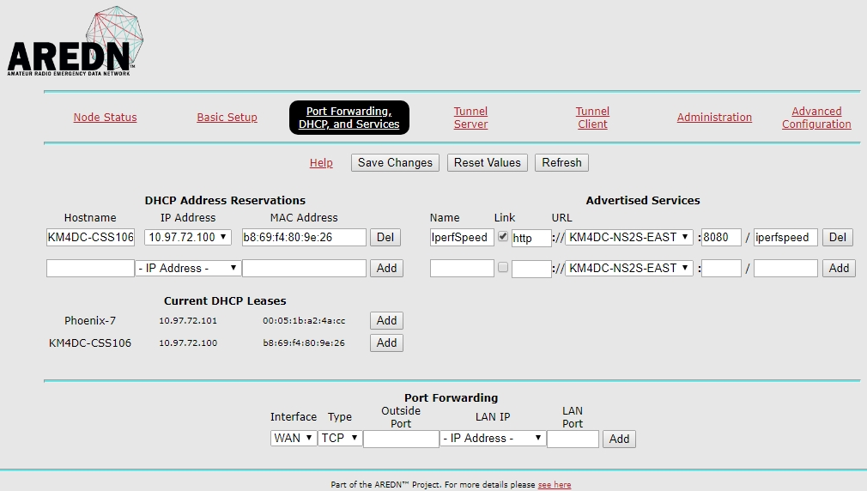
The AREDN node is showing the MikroTik switch and my PC connected.
The MikroTik managed switch with POE out on ports 2 – 5 is about $60 on Amazon.
https://www.amazon.com/Mikrotik-RB260GSP-Gigabit-Ethernet-Ports/dp/B00KAXCVQ8/ref=pd_cp_147_1?pd_rd_w=nSkr9&pf_rd_p=ef4dc990-a9ca-4945-ae0b-f8d549198ed6&pf_rd_r=1EE1QYX2ADHMHCC1FBSP&pd_rd_r=03e3b711-a94a-11e9-85ce-aff8187a0e51&pd_rd_wg=PXPPa&pd_rd_i=B00KAXCVQ8&psc=1&refRID=1EE1QYX2ADHMHCC1FBSP

