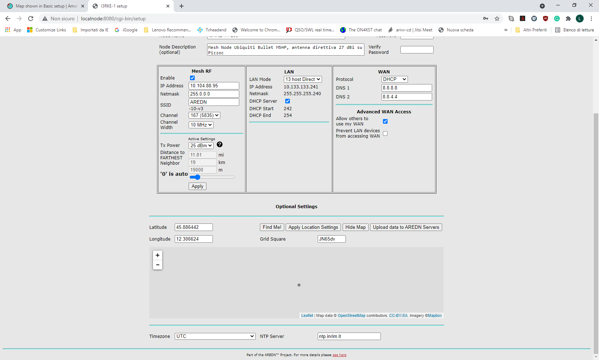
This is the map shown in one node located on 45.886440 N – 12.306633 E (only a dot).
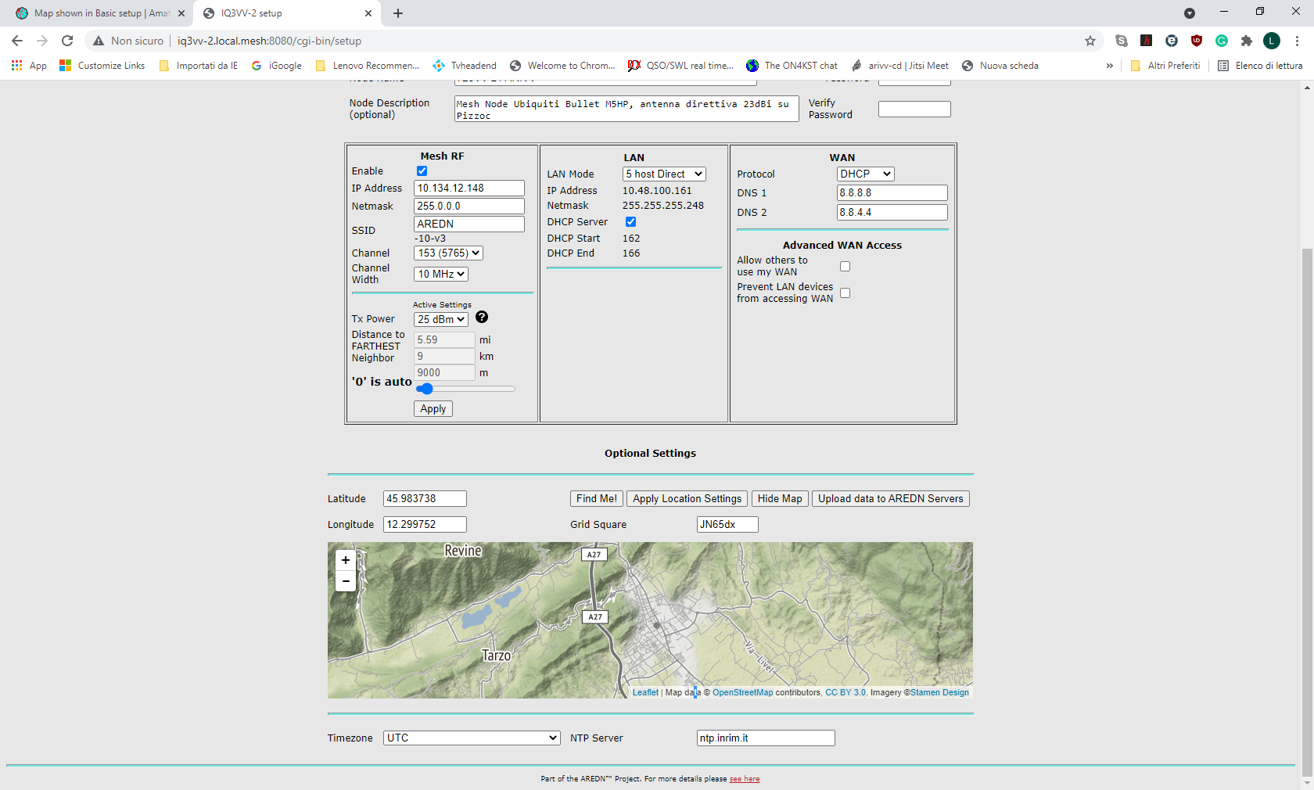
And this in another node located on 45.983738 N – 12.299752 E (definition seems good, but zooming the map disappear and remain only a dot). Both are Ubiquiti Bullet M5 HP

