In this docs the whole mesh as seen from the top of the two hills. One where are co- located IR3UFR-1 and IR3UFR-2. The other where is located IQ3QR-1.
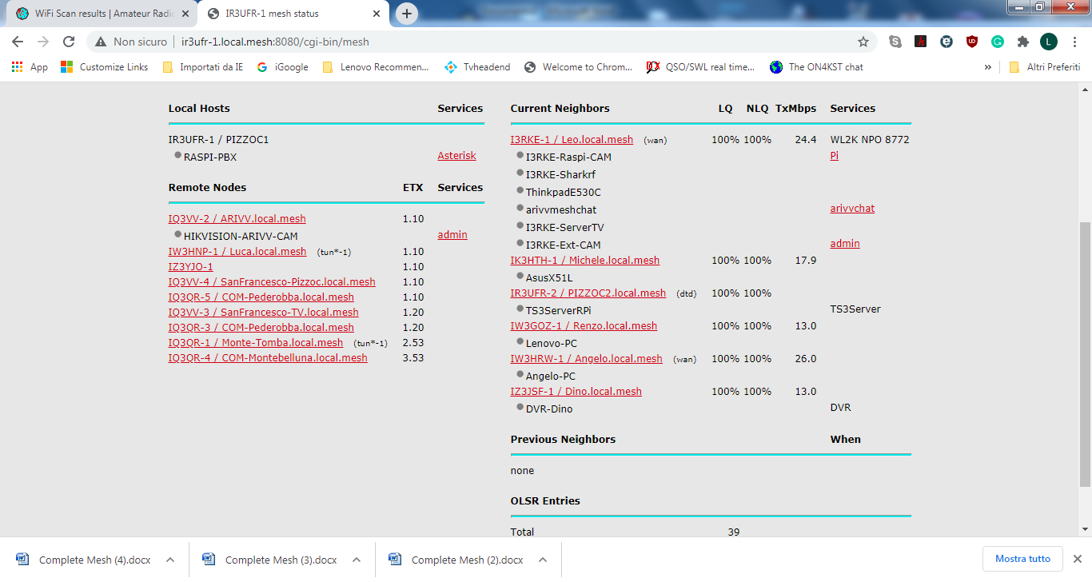

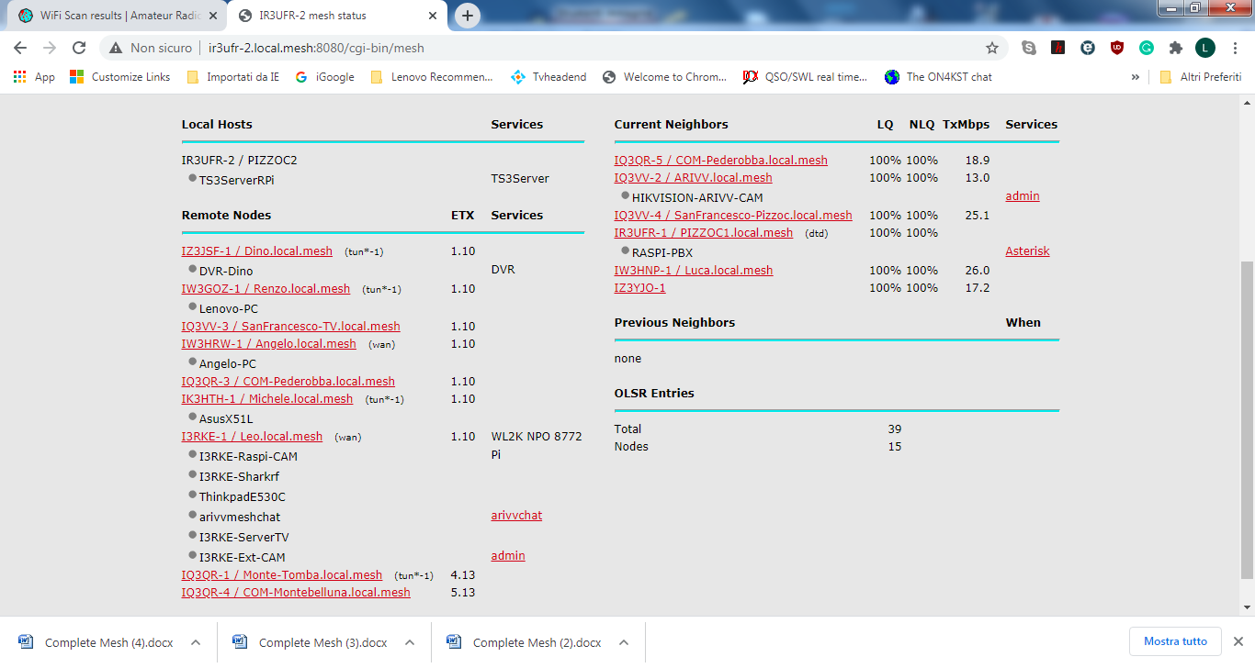

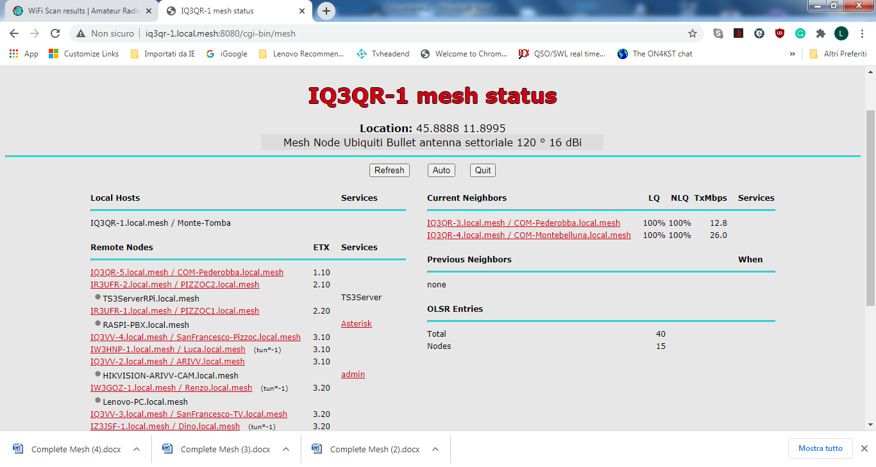
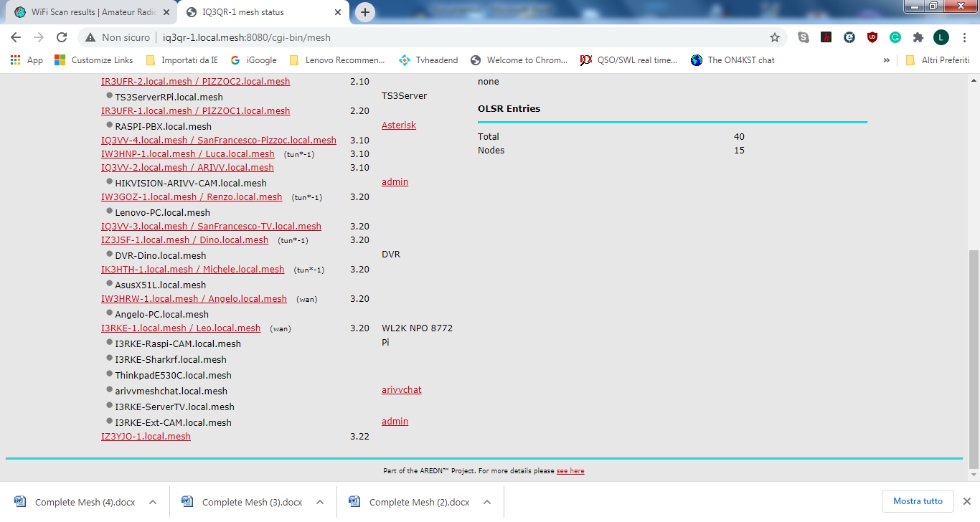
At the time of this screen-shot the link resulted perfect ! (two screen-shot to take the full picture !).
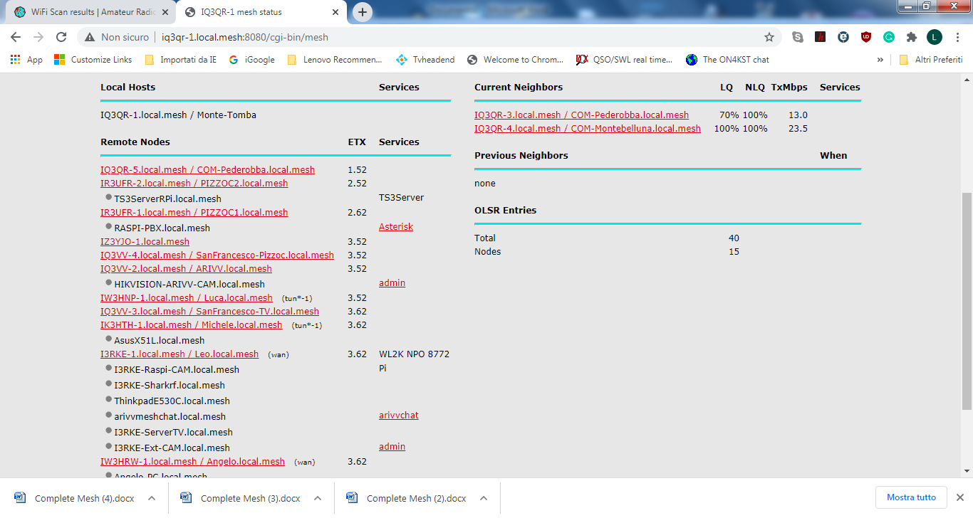
Few minutes later bad.

