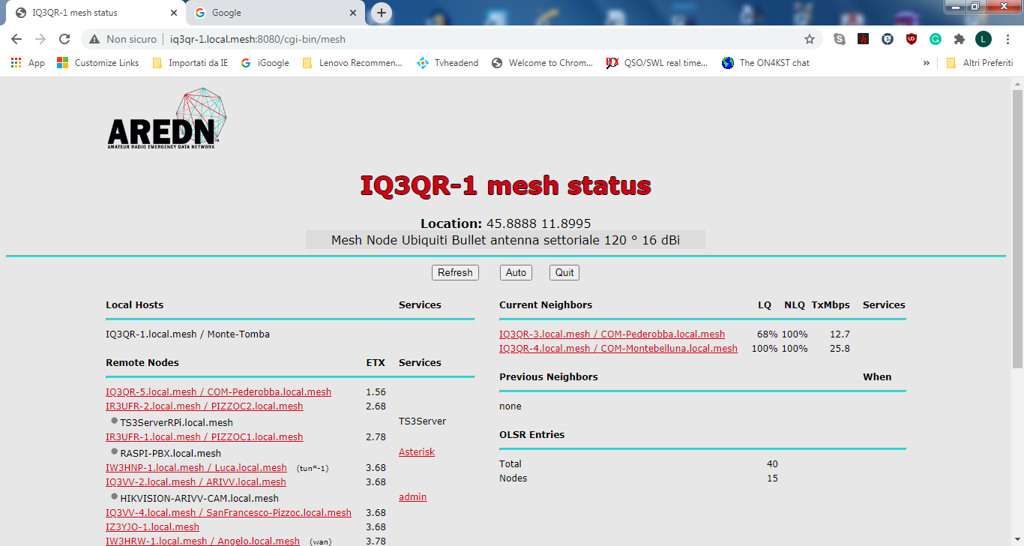
The node IQ3QR-1 is located up a hill and the IQ3QR-3 and IQ3QR-4 are downhill. IQ3QR-3 is loosing 32% of the packets.
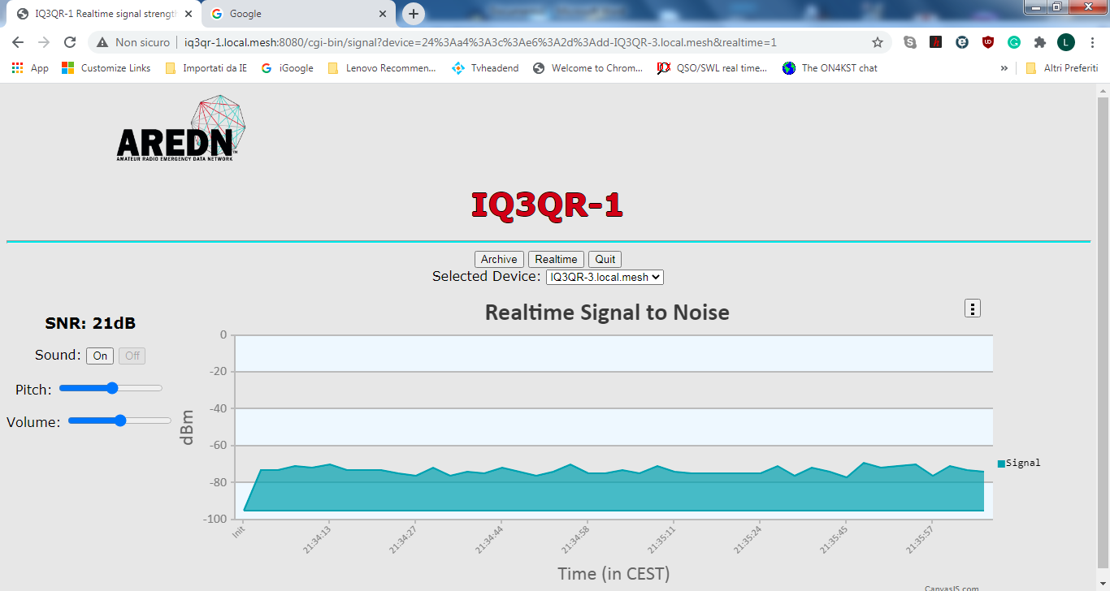
IQ3QR-1 from IQ3QR-3
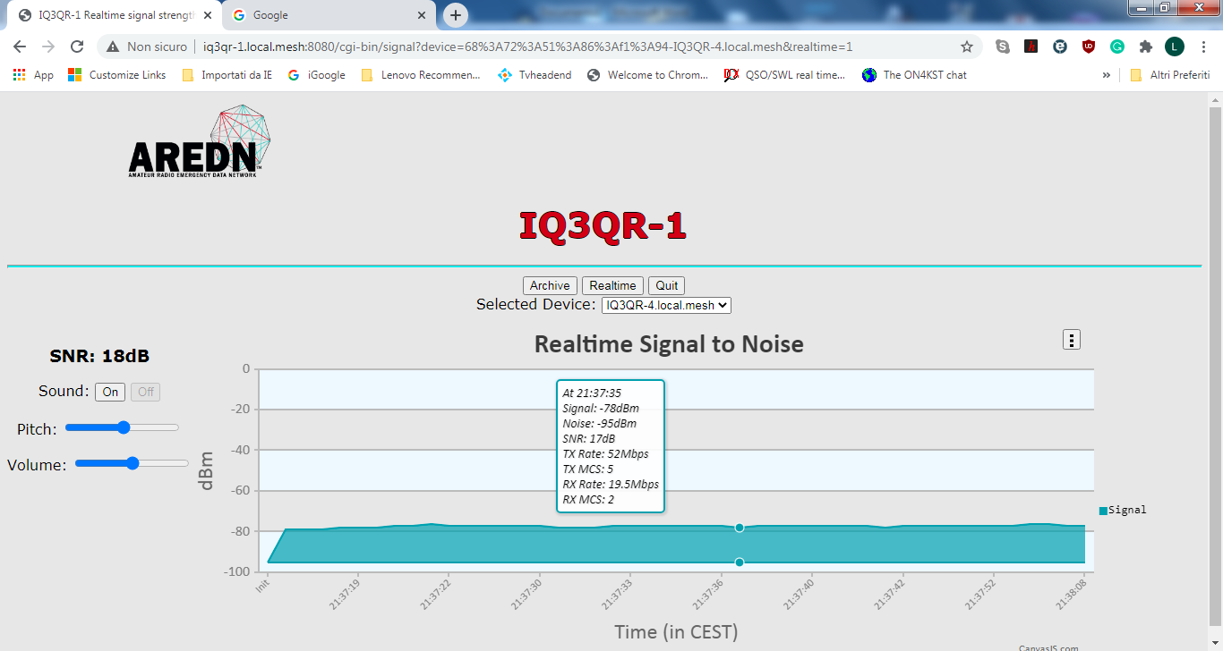
IQ3QR-1 from IQ3QR-4

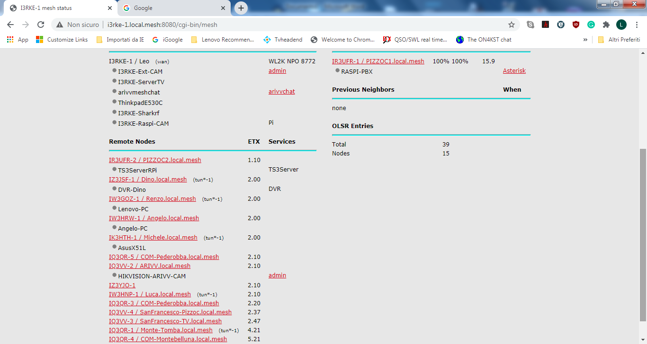
Here the complete mesh that is working fine in all the segments, but not at IQ3QR-3 to IQ3QR-1 in which the ETX should be 3.20 and not 4.21.

