ECAN – Emergency Communications AREDN Node.
It can be done

Greetings,
As part of the AREDN team of networks it is always important to be active in the ongoing development of its software, hardware components and deployment. When you have a [AREDN] service package that you want to, design, assemble than deploy it must have the ease of set up and operation but, also be lightweight. I wanted a unit that was light, deployable both in a mobile and portable configuration that could be deployed by a two (2) man/women team. It also needs to be a flexible communications unit to interface with other technologies and upgrades {software, components etc.}. I call it, ECAN or Emergency Communications AREDN Node(s). I assembled a service package that would serve and operate at an ICS-Incident Command Site fixed base station operating in a portable or in a mobile configuration for automobiles or even in a fix-wing or rotor-wing aircraft. My package is contained in a pelican case which holds a, Mikrotik Hap-ac-lite, Raspberry pi 4 form factor computer {with mouse, keyboard and 12" color monitor}, 12VDC to 110 AC Inverter with two outlets and a 5VDC five input charging port recharging station which will be used to recharge smart devices and the 110VDC outlets to operate and recharge a laptop PC. The unit would be able to add other AREDN components in a dtd configuration as needed for network expansion

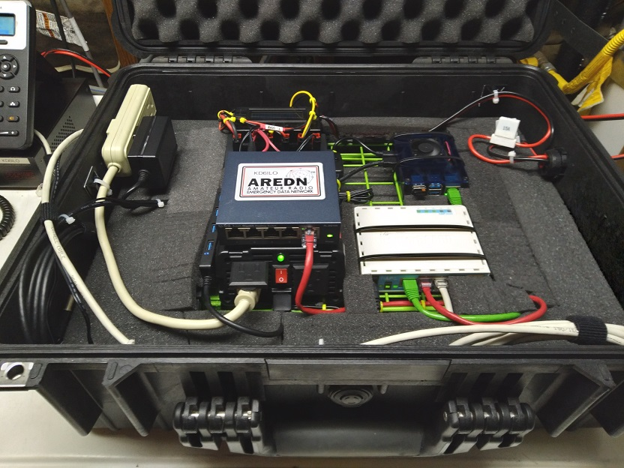
ECAN a Portable / Mobile AREDN Deployable Service Package.
Note: Not all supporting components shown.

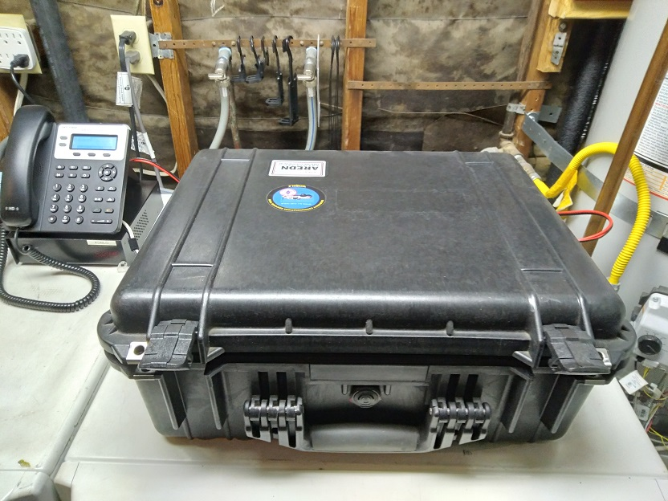
Unit closed with a Grandstream, Model: GXP1620 VoIP SIP Phone top left.

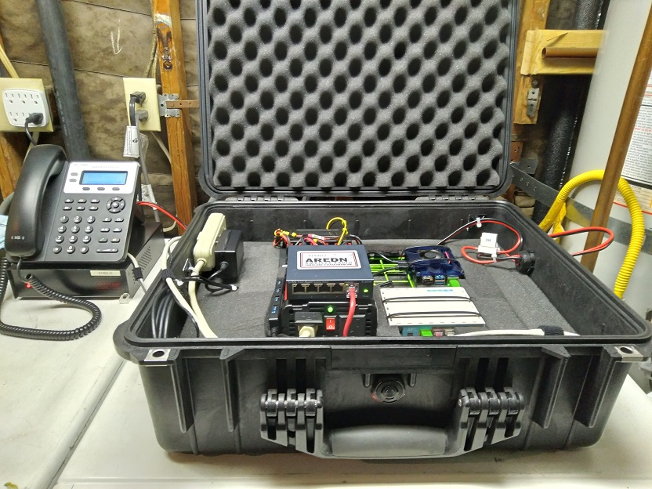

KD6ILO-PORTABLE-6-CA-HAP [Node 6A]
[Node 6B] not shown is the Manpack dtd support package

