How to install AREDN firmware on MikroTik using a Windows computer.
All credit for this approach goes to Ray Suelzer, KK6RAY (formerly KM6WUH)
whose video can be viewed here: YouTube here.
You will need:
Tiny PXE: Download this software (http://reboot.pro/files/file/303-tinypxe-
server/)
The AREDN Mikrotik firmware from the AREDN Nightly Build
A pen, bent paperclip, or toothpick to press the reset button on the
MikroTik device.
1. Add the following line to the DHCP section of the Tiny PXE config file
(config.ini): rfc951=1
2. Rename the Blah_Blah_Blah.elf file to: rb.elf and place the file in the
Tiny PXE "file" sub-directory.
3. Turn off your computer's wifi radio.
4. Set your computer to a static IP of 192.168.1.10
5. Connect the computer's ethernet port to the Mikrotik's wan (internet)

port.
6. Power up the Mikrotik.
7. Load Tiny PXE.
8. Bind the Tiny PXE program to your IP of 192.168.1.10
9. Point the program to the rb.elf file location.
10. UNCHECK the box labeled: “Filename if user-class=gPXE or iPXE”
11. Prepare to party ... :)
12. Remove power from the MikroTik.
13. Click “Online".
14. Press "Reset" and hold it.
15. Power up the MikroTik.
16. Continue to hold "Reset" until the rb.elf file is loaded.
17. Click "Offline".
18. Take a deep breath .... do NOT remove power from the MikroTik :)
19. If you are doing the hAP ac lite: Move your cat5e cable to a LAN port on
the MikroTik .... any port (port 2 for me) except the Internet port or eth4 which is DtD.
20. Open your browser and point it to: http://192.168.1.1/
21. Log in with user name: root and password: hsmm
22. Go to the Administration page and upload the firmware upgrade
file. Wait for the Do not remove power message to go away for maybe 3 minutes. The USR light will be blinking. This link will help to select correct file:
(http://downloads.arednmesh.org/snapshots/trunk/readme.md)
23. Pray.

The firmware is being updated.

DO NOT REMOVE POWER UNTIL UPDATE IS FINISHED

Firmware will be written in the background.

If your computer is connected to the LAN of this node you may need to acquire
a new IP address and reset any name service caches you may be using.

The node will reboot twice while the configuration is applied
When the node has finished booting you should ensure your computer has
received a new IP address and reconnect with
http://NOCALL-32-137-55.local.mesh:8080/
(This page will automatically reload in 3 minutes)

24. Reset your computer from static to dynamic DHCP.
25. When the node reboots you can begin normal configuration ... start with
a new node name and password.
26. Congratz! :)
192.168.1.1 gets you back to the NOCALL-32… if all is correct so far

http://NOCALL-32-137-55.local.mesh:8080/

Now go through AREDN page the setupIf something goes astray you can try to connect with
http://localnode.local.mesh:8080/
or
http://AG6ST-HAPAC.local.mesh:8080/
192.168.1.1 gets you back to

NOCALL-32-137-55
Location Not Available
You need to run setup in orderfor it to get these new ip names
Login / password does not work
Trying no password with logid of AG6ST only and changed distance
Password must be changed error
Put in my normal simple password
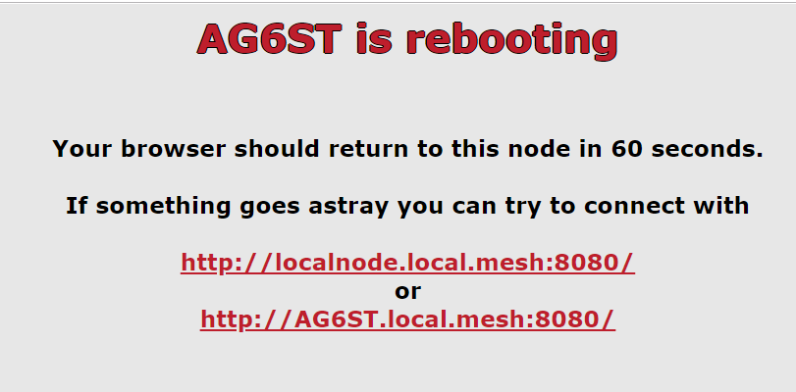
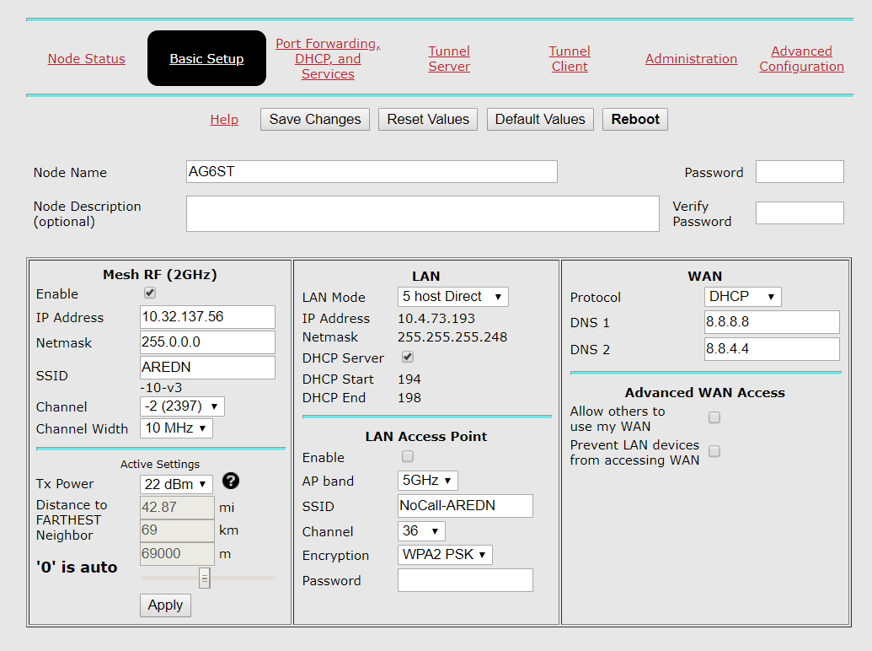

Changed to DHCP on the Ethernet properties

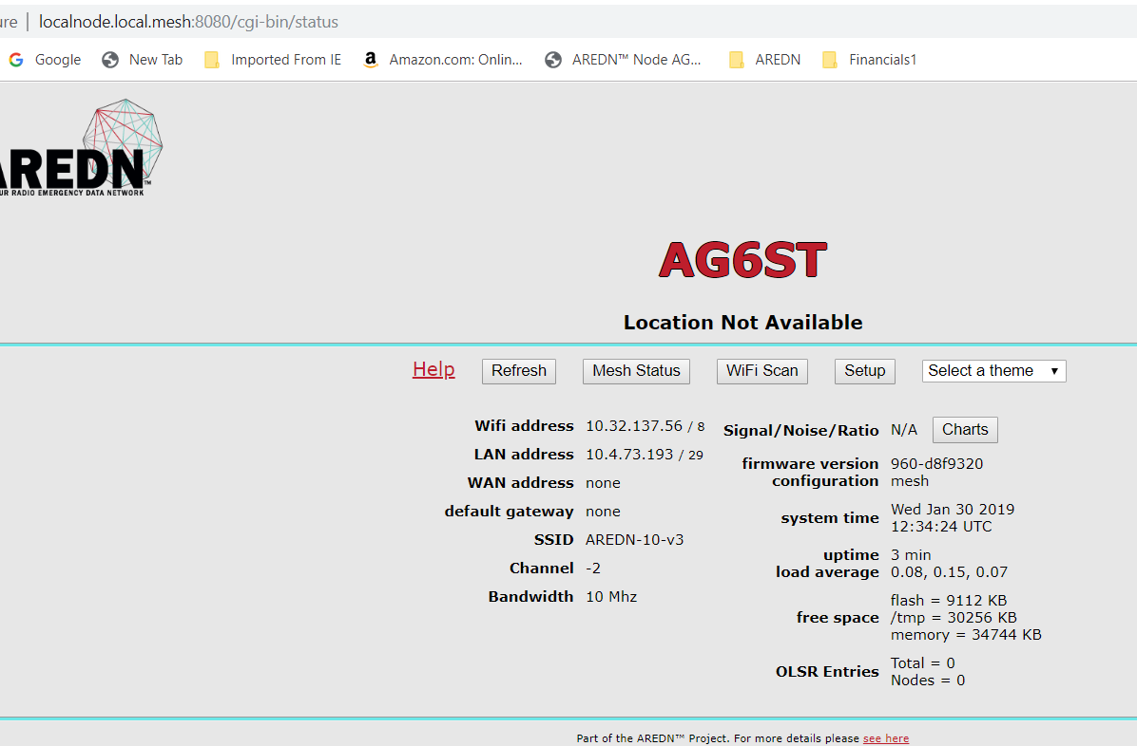

It will not accept my AG6ST and password that saved at the initial setup
It just flashes, repeats the logid/password log screen
Authorization Required

